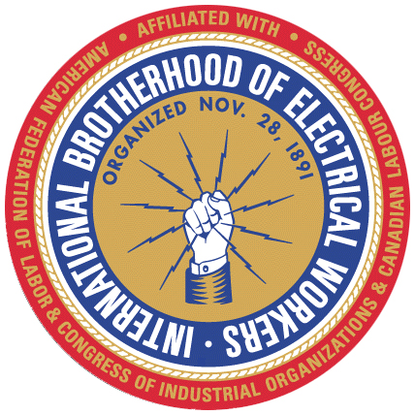

LOCAL UNION 1289
P.O. BOX 1690 WALL, NJ 07719

PLEASE POST May 21, 2026 PLEASE POST
To: All Members

Re: Election Judge

Brother Brad Fulmer has been appointed as the Judge of Elections. All questions and concerns should be directed to Brad via email fulmerbradford@gmail.com or phone 908.625.7872.

Appointed tellers for the election

South North

1. Kathy Hempstead 1. Ray Alicata
2. Sara Shannon 2. Jim Floyd
3. Tara Daly 3. Tom Trautz
4. Randy Trembley 4. Tom Balancia

VOTING WILL BE IN PERSON ON JUNE 18, 2026.

Voting will be held at the IBEW Local 400 in Wall, and the Clinton Firehouse, in Clinton. Hours for the vote will be from 6:00 am to 6:00 pm at both sites.

Fraternally,

Domenic Lazzaro
Recording Secretary
IBEW, Local 1289

