IBEW, LOCAL 1289’S MERCHANDISE STORE
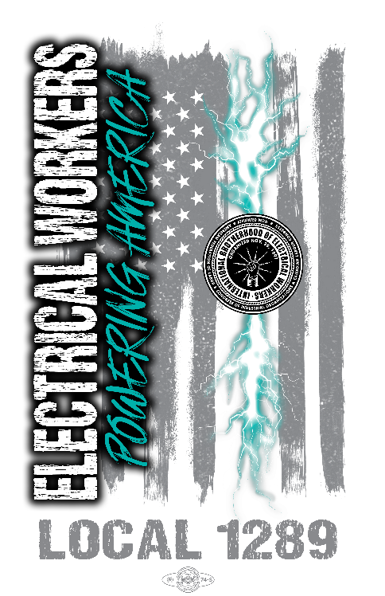
Local 1289 is pleased to announce the merchandise webstore is now open. Orders must be placed by August 5, 2026 and will be shipped week of August 24, 2026.
Please use the below link:
stores.cedarstream.com/ibew_local_1289/shop/home

Happy Shopping!

